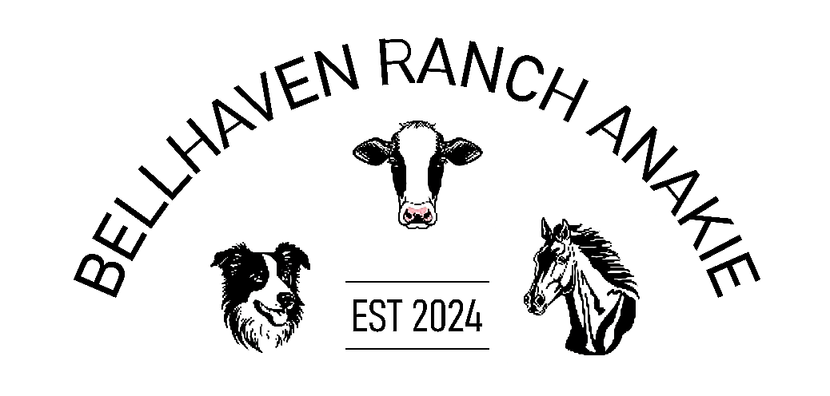
STALL HOLDER AGREEMENT BETWEEN the ANAKIE RODEO (BELLHAVEN RANCH)- and - __________________________________________________________________________ (Called “the Stall Holder”),
1. STALL HOLDER INFORMATION: Please print your Company name, address, phone number & information as you would like it to appear in any advertising:
COMPANY NAME: ___________________________________________________________ Address:____________________________________________________________________ ___________________________________________________________________
Mailing address (if different than above): ____________________________________________
Office Phone #: ______________________ Alternate Phone #: ________________________
E-mail: __________________________
Website: ___________________________________
Permission to promote your business information on the ANAKIE RODEO/BELLHAVEN RANCH website: YES ______ NO _____
AUTHORIZED SIGNATURE: ____________________________________________________
PRINTED NAME: ____________________________________________________________
2. REQUIREMENTS
Stall size required in square meters: _______________________________________________________
Is mains power required? (circle) YES / NO
Will you have your own generator? (circle) YES / NO
Public liability insurance currency? (circle) YES/ NO
Food handling currency? (circle) YES/ NO
Please List all products that you will be selling:______________________________________________ ____________________________________________________________________________________________________________________________________________________________________________________________________________________________________________________________________________________________________________________________________________________________________
4. FEE
For food stalls, the Stall Holder agrees to pay the sum of $120
For non-food stalls, the Stall Holder agrees to pay the sum of $50
5. PAYMENT: Payment for the stall MUST accompany your agreement at the time of booking. If payment is not included or payment arrangements have not been made your stall is NOT guaranteed & can be reassigned. The ANAKIE RODEO/BELLHAVEN RANCH reserves the right to restrict the promotion of the stall holder until payment is received in full. Payment can be transferred to:

Account name: Bellhaven Ranch
BSB: 063-866
Account: 1024 3426
Reference: Your business name
Description: Please state either Food Stall or Non-Food Stall

Date: __________________________________ Authorized Signature: ____________________________

TERMS AND CONDITIONS The Stall Holder acknowledges that he/she has read the Terms and Conditions of this Agreement and agrees to be bound by them.
1. No Stall Holder will be offered exclusivity regarding products or services, however, we will endeavour to minimize similar stalls/products. The ANAKIE RODEO/BELLHAVEN RANCH reserves the right to limit the number of companies offering similar products and services.
2. Stall Holders of this event have the first option for future stall sites at our events. The renewal deadline is 2ND AUGUST each year, to guarantee your spot. After this date, all unallocated sites will be made available to other interested parties on a first-come / first-served basis.
3. The Stall Holder must set up at their allocated site and can not change. Sites will be allocated 2 weeks before the event.

